**Sprint 3 Retrospective**

**Product:** SquadUp

**Team:** The Big Ballers

**Revision date:** 7/24/2018

**Actions to stop doing:**

Stop overestimating how much work we can do in a week with numerous classes and obligations.

Stop cramming many hours in during a 5 week summer course. This causes a lot of stress and makes the project a lot more stressful than it should be.

**Actions to start doing:**

Keeping the communication that we have in person and in the remote pipeline the same consistency. It is very difficult to always be in a work environment outside of the project jam sessions and class.

Start modifying the production sheet every day. Every hour should be logged and accounted for, plus the roadblocks that come up need to be addressed as soon as possible.

**Actions to keep doing:**

Keeping up to date on our documentation to keep all members up to date on how the software parts coincide with one another. We should keep our scrum meeting times in the afternoon because this accommodates all the members schedules.

Keep the workflow in our project jams the same as it has been. Take 3 hours on our meeting days to work together in a group. After these meetings we will keep holding the scrum sessions.

Keep the increased communication levels. This helps with productivity and troubleshooting if team members need help with a certain roadblock on their tasks.

The pair programming that we did in sprint 2 was very effective and helped all team members with their task progress.

**Work completed/not completed:**

The user stories completed are as follows:

1. User Story: As a user, I want all pages to be functional to use the web app as intended.

2. User Story: As a developer, I want to make API call to the backend, so that the client can get data.

The user story that was not completed:

1. User Story: As a developer, I want to test every page for bugs and functionality to make the polish of the web app better.

**Work completion rate:**

After assessing the tasks for sprint 3, we completed 2 user stories and had 1 pushed back to the product backlog.

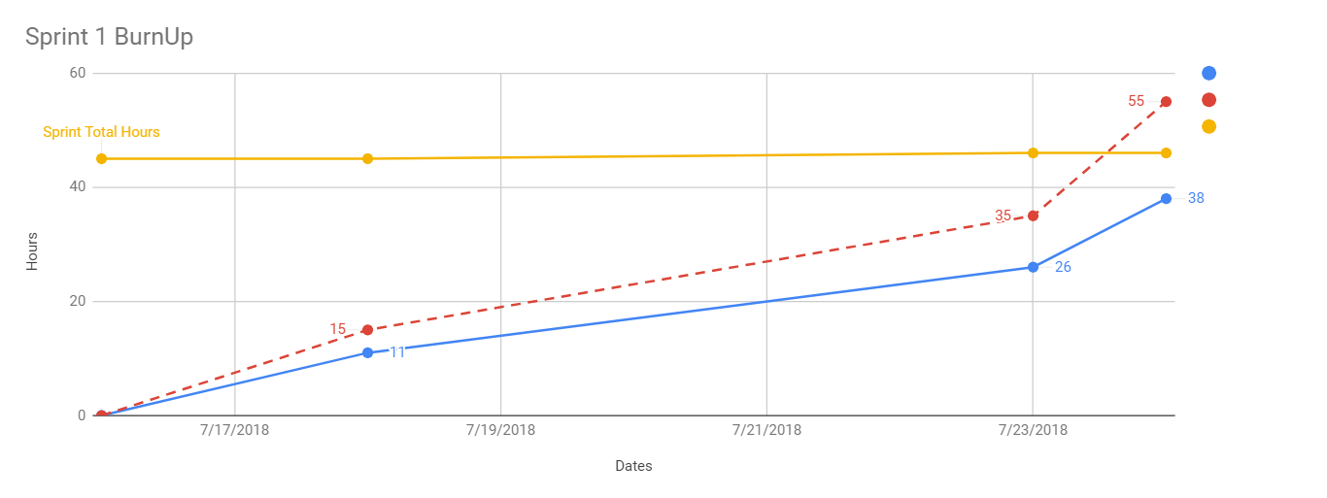

The burnup chart shown has a key, blue being estimated hours completed, red being the actual hours completed, and yellow being the total estimated hours. Just by looking at the chart it is obvious that we underestimated the hours necessary to complete the tasks for user stories 1, 2 and 3. The amount of actual hours was 55 hours, and the estimated total hours was 36 hours. This is in between our sprint 1 and 2 estimates. We are over by 17 working hours. This shows that the underestimate in the tasks might have been caused by not utilizing any testing methods or could have been to just ramping up on the technologies that we learned. The average ideal hours per day was 5.42. While the average actual hours per day was 7.85. The average user story completed per day was 0.42.

The cumulative chart is as follows:

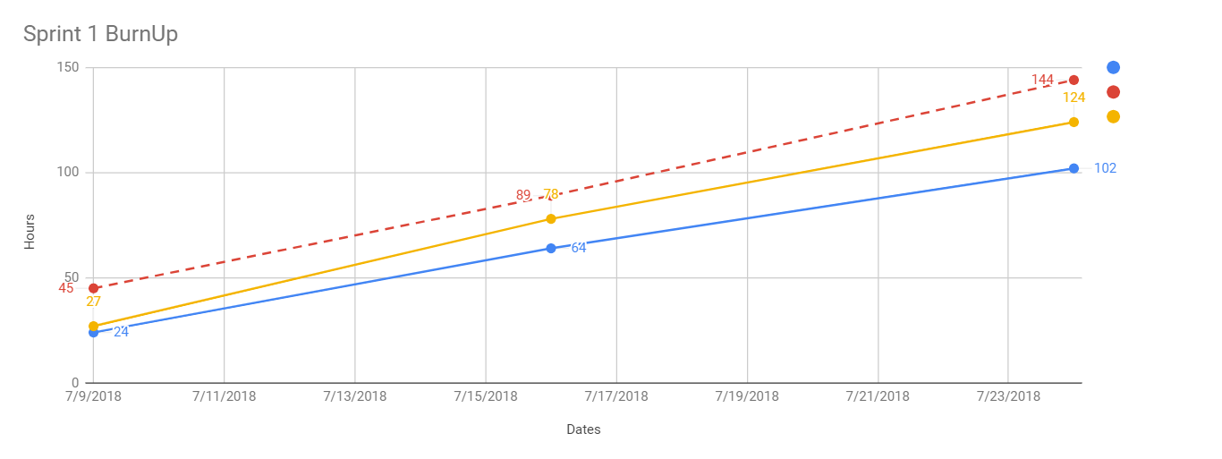

This shows that we were behind schedule the entire release. By the end not all user stories were completed and hour actual hours surpassed the estimated ideal hours by 42. This gap could be caused by technical debt by not following engineering practices while we were utilizing scrum.